
Development Request
Aria Systems
Allocate P/O to a Customer

Custom Program # ???

Screen Template

Product: | Aria 2.7
Module: | PO
Customer name: | GMA
Add-In Name: | Allocate P/O to a Customer
Installed Modules: | All modules except PS.
Parameters setting: | (see the Setting file)

Details Section
Add-In Name: Allocate P/O to a customer
Existing Initial situation: Currently, Aria has the option to allocate certain P/O to sales order(s). This is done currently through the Style PO Allocation screen or the Generate PO from Sales Order options.
However, GMA allocates the P/O in a different way. GMA issues the Style PO in most cases to a specific Customer in general and not to a specific sales order. Later on, when the customer sends the order confirmation, we allocate the P/O to individual sales order(s).

Screen Objective:
- To have the ability to assign the P/O to a Customer code.
- To force the PO Allocation to be done for Sales Orders belong to this customer only.

Description:

To achieve the mentioned above, modifications in these screens/programs will take place:
- Style PO screen, to add a new field to populate the Customer 5 digit code.
- Style PO Allocation: to validate that only sales orders for this customer are being allocated to the P/O.

- Style PO screen:
A new field will be added to the POSHDR file to hold the Customer code. This field will be populated and validated from the CUSTOMER file for the main account records (Customer.Type = “M”). It can be done as a browse field or popup.
Customer Field can be added in this place.
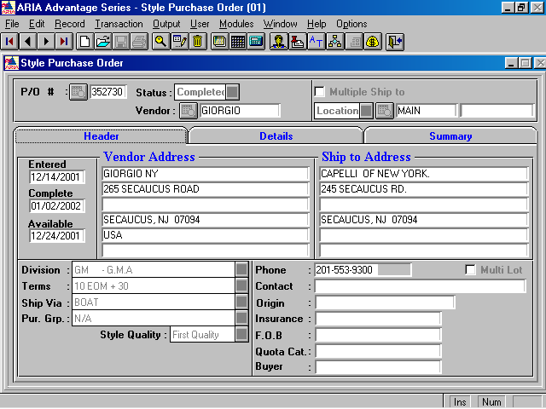
Note: we don’t use Multi Currency and the new Customer field can be added as indicated above if possible. It should be optional (not mandatory) and editable.

- Style PO Allocation screen:

The Style PO Allocation screen should be modified to validate the new field POSHDR.Customer and show only the sales orders related to this customer. If the Customer field is empty, then it’ll show all sales orders as it does currently.

